New year, new me!

24

**by :**

GraceL

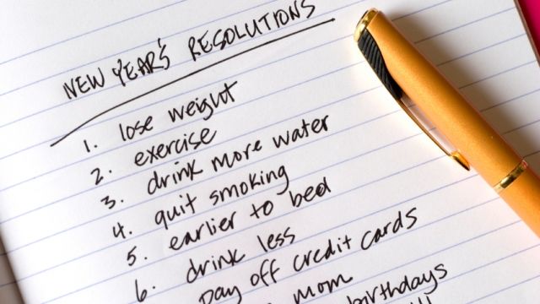

"New year, new me" is a phrase you often hear in the UK on the first of January. It is very common to start a new year's resolution on this day. This can be to give something up, like sweets or chocolate, so you can be healthier. People also like to start doing something new, like taking up a new hobby or going to the gym, so you can get fitter. There are so many things you can do! Most of the people I know decide to join a gym and eat healthier food as their new year's resolution. Many gain weight after the Christmas period as they often eat a lot of fattening food!

I think new year's resolutions are a great idea to give people the motivation to do something good for themselves. When a lot of other people also have a resolution it helps you to stick to your own. A resolution to get fit could be done between a group of friends. They could arrange to go jogging a couple of times a week. Group resolutions can be so much more fun! In the past I have given up chocolate, stopped eating meat, recycled more, joined a gym and started karate! Some of these things I soon gave up on, not eating chocolate for example, and some I persevered with and still do now. I think it is important to choose something that is realistic for you.

This year my resolution is to travel less by plane. Living in the UK, it was very difficult to travel without a car and not by plane but now that I live in Germany I find it much easier to travel long distances by another mode of transport. There are more environmentally friendly options that I can choose like travelling by train or bus and though it is more expensive, I know that I will be damaging the environment much less.

Language level:

[B2](https://learnenglishteens.britishcouncil.org/level/b2-cefr/term)

Topics:

[new year](https://learnenglishteens.britishcouncil.org/topics/new-year/term)

[new years resolution](https://learnenglishteens.britishcouncil.org/topics/new-years-resolution/term)

Discussion

Do you have a new year's resolution? How do you think you can achieve it?