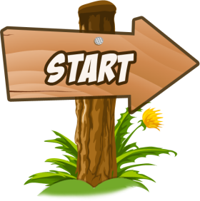 | How many pupils are there? | Where are  they? | Who is in front of the whiteboard? | What subject are they learning? | Where is the yellow ruler?
Who is painting a horse? | 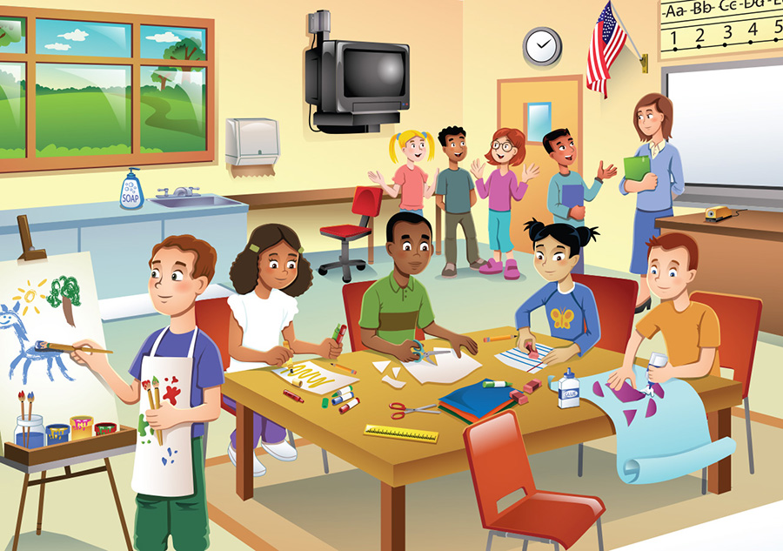  ALI  TIM  LENA  SAM  PAUL |  |  |  | How many pupils wear glasses?
How many children are sitting? |  |  |  |  | Where is the flag from?
What colour is Sam’s T-shirt? |  |  |  |  | What is Paul drawing?
Who is using a pair of scissors? | How is the table? | who is talking to the teacher? | What is Ali doing? | What time  is it? | Where is  Lena?
 | There are 9 pupils. | They are in a classroom. | The teacher is in front of the whiteboard. | They are learning Art. | The yellow ruler is on the table, next to the scissors.
Paul is painting a horse. | ALI  TIM  LENA  SAM  PAUL |  |  |  | 1 pupil wears glasses.
Four children are sitting. |  |  |  |  | The flag is from The USA.
Sam’s T-shirt is orange. |  |  |  |  | Paul is drawing a horse.
Ali is using a pair of scissors. | The table is big and brown. | Tim is talking to the teacher. | Ali is cutting out a paper. | It’s ten past ten. | Lena is next to Ali.

