New Year's celebrations around the world

4

**by :**

PhoebeBlogger2

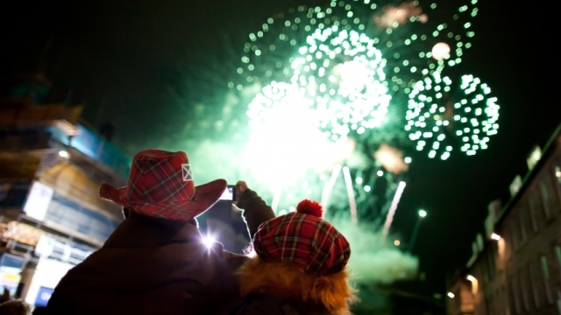

New Year's Eve is a different time for everybody all around the world.

In England, where I am from, we usually have a party with friends and family. We put the TV on and wait for Big Ben to hit 12 and then we all wish each other 'Happy New Year', cross our arms across our chest and hold hands with the person next to us. We form a circle and sing a song called 'Auld Lang Syne', a very old Scottish song which means 'times gone by'. We make New Year's resolutions too, a list of things we say we will do in the New Year. For example, travel more or spend more time with family.

In Spain, when the clock hits 12, people eat 12 grapes! Twelve represents the 12 months in a year. It is believed if you eat the grapes, you will have good luck for the whole year. In the town I am working in here in Spain called Casariche, everyone will join each other on the street to eat the grapes and will be dressed up.

In Greece, lots of children receive money for New Year's and when midnight hits, children or the head of the family will be sent out of the house and told to walk back in. The 'first footing' is how it is named; this brings good luck. We also have this tradition in England! They also have a St. Basil's cake, a cake with a coin baked inside it, and whoever gets the slice of cake with the coin in will be especially lucky in the New Year.

In Denmark, people smash plates around the front door of the house. It is said that the more plates you break, the more friends you will meet in the New Year. They also jump from a chair when the clock strikes midnight!