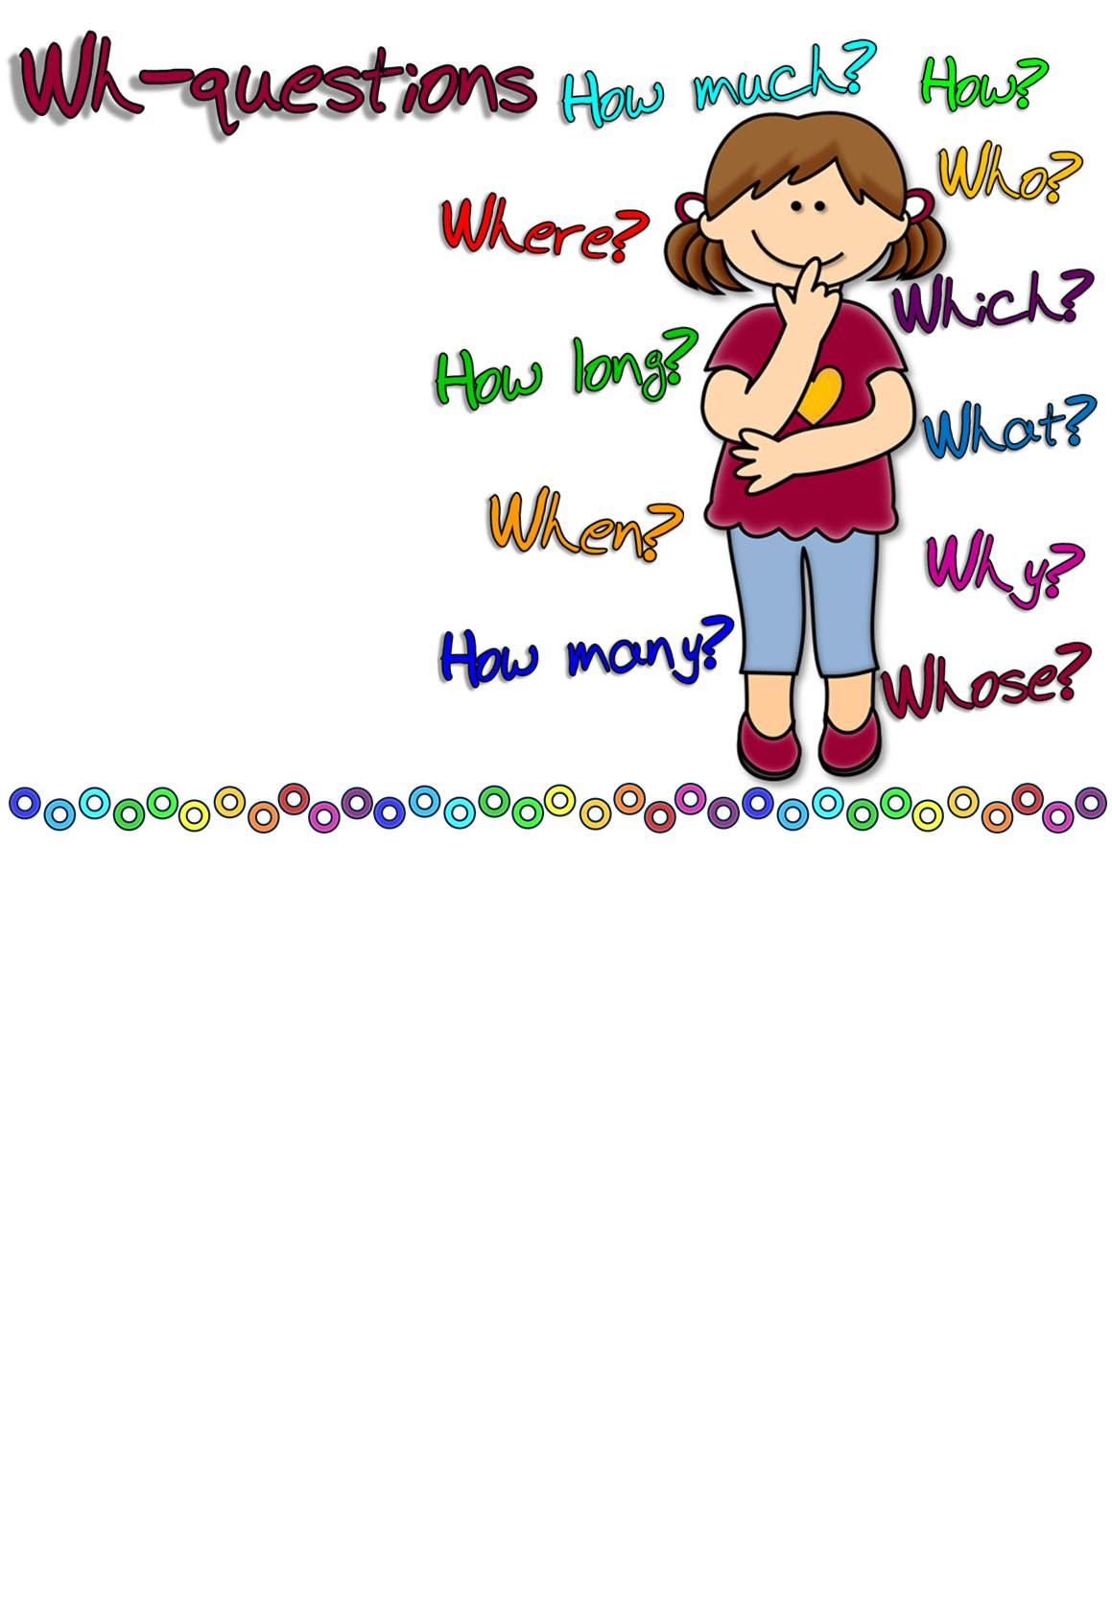
_ _ _ _ _ _ _ is Daniel watching on TV?
_ _ _ _ _ _ _ are the trees in this park?
_ _ _ _ _ _ _ shoes are you going to wear with your dress?
_ _ _ _ _ _ _ do your parents leave you home alone?
_ _ _ _ _ _ _ shut the window?
_ _ _ _ _ _ _ is Chicago from New York?
_ _ _ _ _ _ _ cheese do you need to prepare the salad?
_ _ _ _ _ _ _ are my keys? Have you seen them?
_ _ _ _ _ _ _ dog is that?
10. _ _ _ _ _ _ _ stamps does Henry’s collection have?
11. _ _ _ _ _ _ _ did Steve come back from Rome?
12. _ _ _ _ _ _ _ do you usually travel on holidays?
13. _ _ _ _ _ _ _ did you reach your destination?
14. _ _ _ _ _ _ _ do you drink milk every day?
15. _ _ _ _ _ _ _ makes you feel happy?
16. _ _ _ _ _ _ _ will Martin study next year?
17. _ _ _ _ _ _ _ daughter is sitting next to Tom?
18. _ _ _ _ _ _ _ do you know that?
19. _ _ _ _ _ _ _ of music does your sister like best?
20. _ _ _ _ _ _ _ did you buy your house?
21. _ _ _ _ _ _ _ is your brother?
22. _ _ _ _ _ _ _ did they go to Paris?
Mrs. Hutchins works in a pet shop.
_ _ _ _ _ _ _ _ _ _ _ _ _ _ _ _ _ _ _ _ _
I’ve bought green suede gloves.
_ _ _ _ _ _ _ _ _ _ _ _ _ _ _ _ _ _ _ _ _
The Nelsons have been our neighbours for ten years now.
_ _ _ _ _ _ _ _ _ _ _ _ _ _ _ _ _ _ _ _ _
My sister played tennis with Megan yesterday.
_ _ _ _ _ _ _ _ _ _ _ _ _ _ _ _ _ _ _ _ _
We’re going to Egypt to see the Pyramids.
_ _ _ _ _ _ _ _ _ _ _ _ _ _ _ _ _ _ _ _ _
Jenny has ballet lessons twice a week.
_ _ _ _ _ _ _ _ _ _ _ _ _ _ _ _ _ _ _ _ _
This schoolbag is Mike’s.
_ _ _ _ _ _ _ _ _ _ _ _ _ _ _ _ _ _ _ _ _
I did. My feet were cold.
It’s our neighbours’.
I think more than a hundred.
I suppose that last week.
Half a pound.
Really late, at about midnight.
Around five hundred items.
His favourite comedy show.
More than a thousand km.
At least once a week.
By car or by plane if it’s far.
On your bedside table.
The purple ones.
My daughter’s smiling face.
About twenty feet.
To see the Eiffel Tower.
Our maths teacher’s.
Rock and R&B.
Because it’ s healthy.
Sue told me.
Five years ago.
In California.
2. Complete the questions with the correct question word and match them to the correct answers.
1. Ask about the underlined part.

1. Ask about the underlined part.

Mrs. Hutchins works in a pet shop.
_ _ _ _ _ _ _ _ _ _ _ _ _ _ _ _ _ _ _ _ _
I’ve bought green suede gloves.
_ _ _ _ _ _ _ _ _ _ _ _ _ _ _ _ _ _ _ _ _
The Nelsons have been our neighbours for ten years now.
_ _ _ _ _ _ _ _ _ _ _ _ _ _ _ _ _ _ _ _ _
My sister played tennis with Megan yesterday.
_ _ _ _ _ _ _ _ _ _ _ _ _ _ _ _ _ _ _ _ _
We’re going to Egypt to see the Pyramids.
_ _ _ _ _ _ _ _ _ _ _ _ _ _ _ _ _ _ _ _ _
Jenny has ballet lessons twice a week.
_ _ _ _ _ _ _ _ _ _ _ _ _ _ _ _ _ _ _ _ _
This schoolbag is Mike’s.
_ _ _ _ _ _ _ _ _ _ _ _ _ _ _ _ _ _ _ _ _

2. Complete the questions with the correct question word and match them to the correct answers.
_ _ _ _ _ _ _ is Daniel watching on TV?
_ _ _ _ _ _ _ are the trees in this park?
_ _ _ _ _ _ _ shoes are you going to wear with your dress?
_ _ _ _ _ _ _ do your parents leave you home alone?
_ _ _ _ _ _ _ shut the window?
_ _ _ _ _ _ _ is Chicago from New York?
_ _ _ _ _ _ _ cheese do you need to prepare the salad?
_ _ _ _ _ _ _ are my keys? Have you seen them?
_ _ _ _ _ _ _ dog is that?
10. _ _ _ _ _ _ _ stamps does Henry’s collection have?
11. _ _ _ _ _ _ _ did Steve come back from Rome?
12. _ _ _ _ _ _ _ do you usually travel on holidays?
13. _ _ _ _ _ _ _ did you reach your destination?
14. _ _ _ _ _ _ _ do you drink milk every day?
15. _ _ _ _ _ _ _ makes you feel happy?
16. _ _ _ _ _ _ _ will Martin study next year?
17. _ _ _ _ _ _ _ daughter is sitting next to Tom?
18. _ _ _ _ _ _ _ do you know that?
19. _ _ _ _ _ _ _ of music does your sister like best?
20. _ _ _ _ _ _ _ did you buy your house?
21. _ _ _ _ _ _ _ is your brother?
22. _ _ _ _ _ _ _ did they go to Paris?
I did. My feet were cold.
It’s our neighbours’.
I think more than a hundred.
I suppose that last week.
Half a pound.
Really late, at about midnight.
Around five hundred items.
His favourite comedy show.
More than a thousand km.
At least once a week.
By car or by plane if it’s far.
On your bedside table.
The purple ones.
My daughter’s smiling face.
About twenty feet.
To see the Eiffel Tower.
Our maths teacher’s.
Rock and R&B.
Because it’ s healthy.
Sue told me.
Five years ago.
In California.

1.
Where does Mrs. Hutchins work?
Who has bought green suede gloves?
How long have the Nelsons been your neighbours?
Who did your sister play tennis with yesterday?
Why are you going to Egypt?
How often does Jenny have ballet lessons?
Whose schoolbag is this?

KEY
2.
- h
- c
- m
- j
- a
- i
- e
- l
- b
10. - g
11. - d

12. - k
13. - f
14. - s
15. - n
16. - v
17. - q
18. - t
19. - r
20. - u
21. - o
22. - p

