



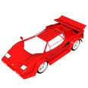


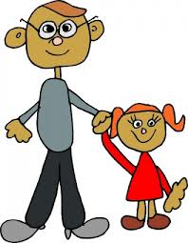

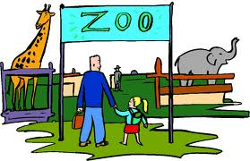


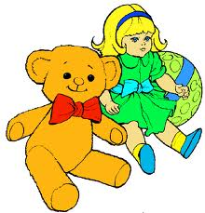
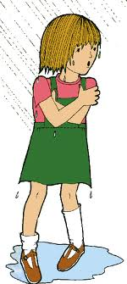
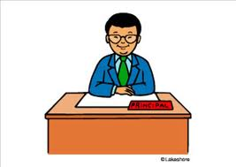
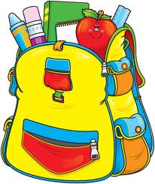





Name:__ _____________
Class:________________

Choose the correct wh-question word
_____is she?
a. who
b. what
c. why
_____ did you make mom?
a. whose
b. what
c. where
______Did the children go?
a. who
b. where
c. whose
_____did he go to work?
a. Who
b. when
c. whose
Is she sad? ______
a. who
b. what
c. why
____car is yours?
a. who
b. which
c. what
______did she go with to school?
a. where
b. whose
c. whom
_____do you fee today?
a. who
b. whose
c. how
did they go?______
a. where
b. what
c. who
_____is your best friend?
a. what
b. when
c. who
____do you see the moon?
a. when
b. what
c. which
_____toy do you like?
a. where
b. who
c. which
_____is she wet?
a. why
b. what
c. when
____did you see at school yesterday?
a. where
b. whom
c. why
____bag is this?
a. who
b. where
c. whose
____happened?
a. what
b. why
c. who
____did this happen?
a. what
b. how
c. which
_____is my cat?
a. what
b. why
c. where
____is that?
a. who
b. where
c. how
____did you do yesterday?
a. where
b. what
c. who
WH-QUESTIONS

